Software Testing Life Cycle

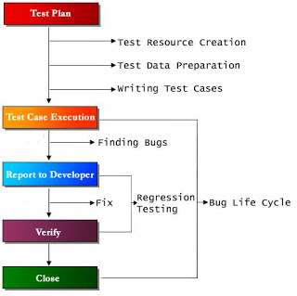
Software testing life cycle or STLC refers to a comprehensive group of testing related actions specifying details of every action along with the specification of the best time to perform such actions. There cannot be a standardized testing process across various organizations, however every organization involved in software development business, defines & follows some sort of testing life cycle.
1. Test Planning
Prepare the test plan document, and test cases.
2. Test Development
Preparing requirements documents, Use Case documents, Traceability documents.
3. Test Execution
Executing all Test cases and filling actual results using testing tools and utilities.
4.Result Analysis
Comparing expected results with actual results.
5. Bug Tracking
Filed bugs are identified, isolated and managed.
6. Reporting
Bug Reporting process is the reporting of bugs in a database to track further.

